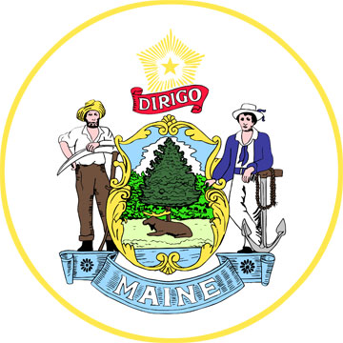 | SIM X Subcommittee  Date:3/19/14  Time:3-5pm  Location: Maine Historical Society, Portland, ME

Chair and Staff: Barbara Ginley(MMHP), Jim Braddick(ME-CDC)

Member Attendance (A-Z): Katelyn Michaud, Kathryn Bourque, Ted Trainer, Kolawole Bankole, Dd Swan, Toho Soma, Kirsten Thomsen, Becca Matusovich, Karen O’Rourke, Meryl Troop, Becky Miller
Ad Hoc Attendance:

Interested Parties:

Members Absent:

Subcommittee documents available at: (insert web address)

Agenda Item/Related SIM Objective (if applicable) | Obj. SST ID | Risk/concern discussed | Escalation to Steering (y/n)
 |  |  | N
 |  |  | N
Agenda Item |  | Discussion Points and Decisions
Announcements |  | 1. Bankole informed the audience that there will be a fundraiser this Friday at the Italian Heritage Center to support the Portland Public Schools ESL..  2.RFP released this morning. Bidders’ conference scheduled for April 1, 1:00 – 3:00 at MCD in Augusta Maine.  3. Upcoming conference: Unity Conference, national conference of CHW’s held in May in Baltimore http://www.usm.edu/health/csho-unity-conference.  4. Launch of website supporting RFP materials, description of materials on this site. Info from Stakeholder Group members and others can be added. The CHWPP would like stories of CHW’s in Maine to add to this site and would like to invite members of the Stakeholder Group to contribute.  5. National Health Service Corps scholarships open for applications.  6. Barbara would like to hear about a case study involving a CHW for presentation/discussion at the upcoming Quality Counts Conference next month.  7. Looking at way to reimburse attendance by CHW’s whose employers will not cover costs.
Review of Minutes from Previous Meeting |  | - Question regarding ICER acronym  - “Advocacy” missing from description of CHW roles.
Common Language for Roles and Responsibilities |  | - Discussion of draft of CHW Responsibilities document, March 17, 2014 Barbara described how she put the document together using materials submitted by participants in the last Stakeholder meeting.  - Inclusion of and reference to CHW definitions from several states, including Minnesota and Massachusetts.  - Discussion of whether and how to develop definition of CHW roles in three tiers related to background, experience, and professional expectations/responsibilities.  - Focus today on developing Tier 1 – basic responsibilities.  - Review of suggestions from Bangor meeting regarding draft Maine definition.  - Definition as encompassing current and future for CHW activities/roles/place in health care system, not tied to CHW roles/activity funded by CHWPP.  - Small group brainstorming and discussion for definition modifications, Group worked from MN definition and collectively decided to step back from work/draft completed in February.
Next Meeting Format
Meeting Evaluation |  | - Nice having small group  - Glad I finally made it  - Nicer space than DHHS office  - Neutral space  - Suggestions for improvement: more involvement of CHW’s , share this work with working CHW’s,
Public Comment

New Actions
Agenda Item | Action Items | Status | Who | Due By
Common Language for Roles and Responsibilities | Barbara to look for sample MA CHW job descriptions to accompany their definition. The work/ mark-ups from the Bangor and Portland meetings will be merged into one document to be shared with the full stakeholder group. |  | BG
 | Barbara to present work completed so far by Stakeholder Group to CHWs in Portland and Lewiston. | BG followed up with Bankole & Dd to set up meetings. | BG | 3/20

Outstanding Actions
Reference |  | Action Items | Status | Who | Due By

